Games, Games, Games!

Why use games?

Games are powerful tools in learning and meaning. Playing for fun is perfectly legitimate but to ignore games as a tool for personal growth and social development is to ignore their wider potential. Games help to create a positive learning environment where skills learned are transferred to the learning landscape.

Games can develop:

- Moral and social awareness.
- Awareness of rules.
- Intra and interpersonal skills.
- The ability to take turns.
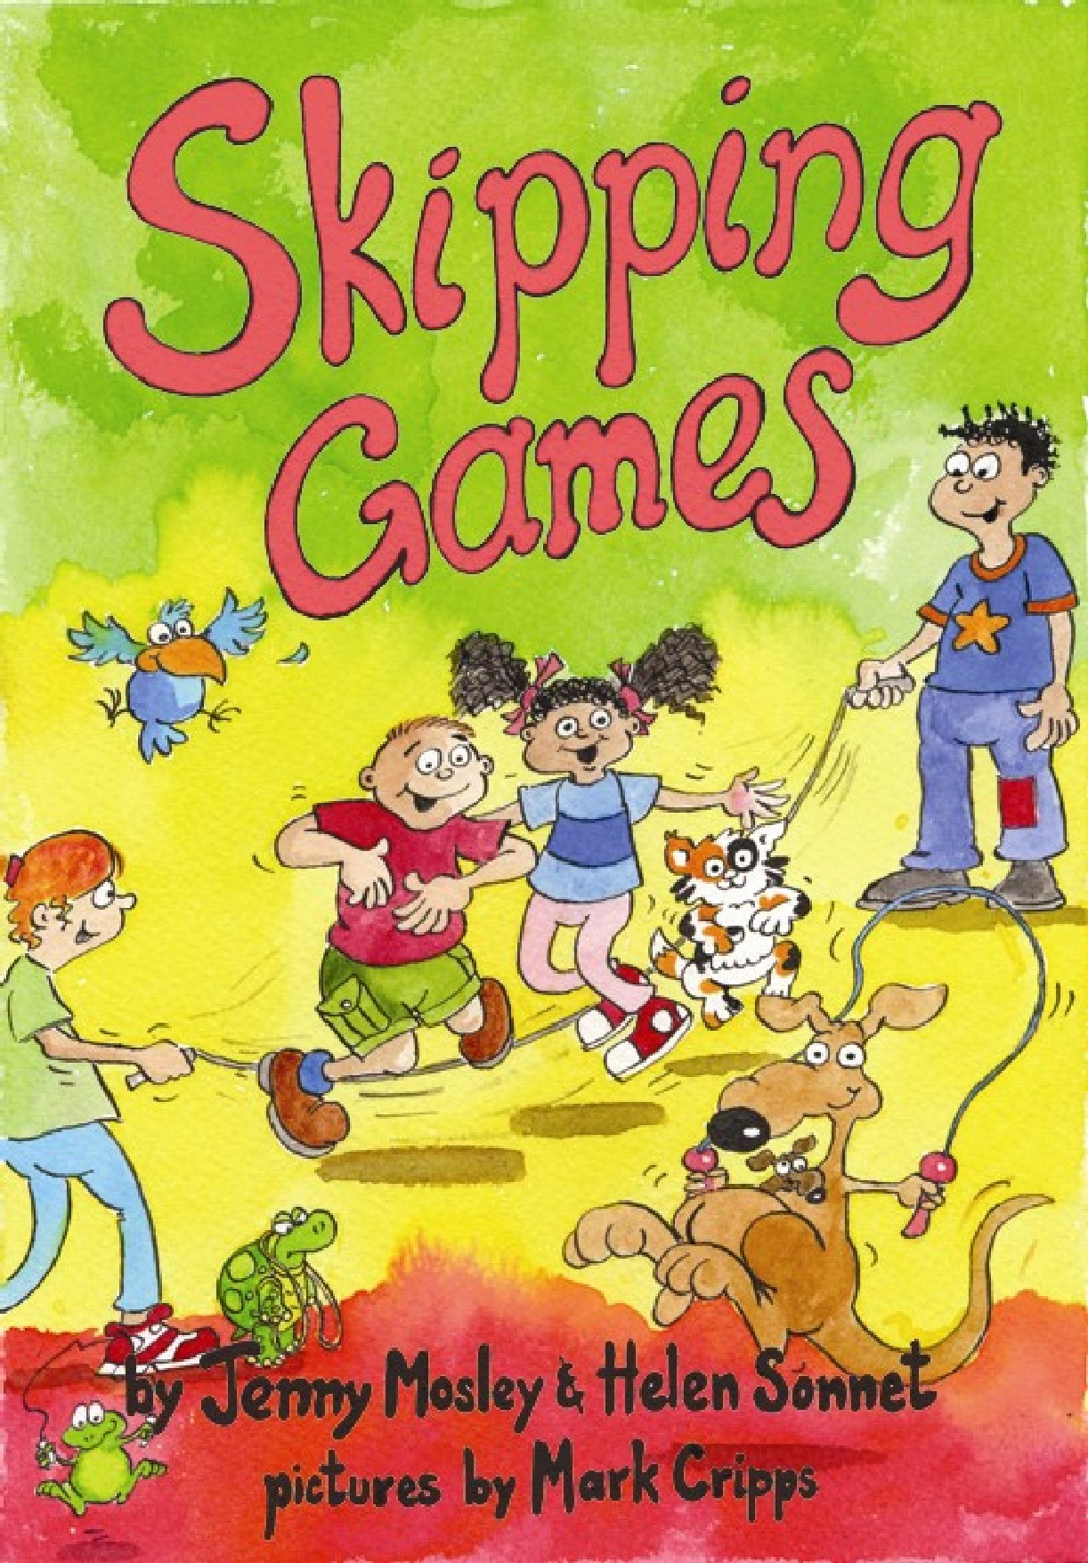
- Co-operation.
- Thinking, looking, listening, speaking and concentrating.
- Motivation.
- Involvement.
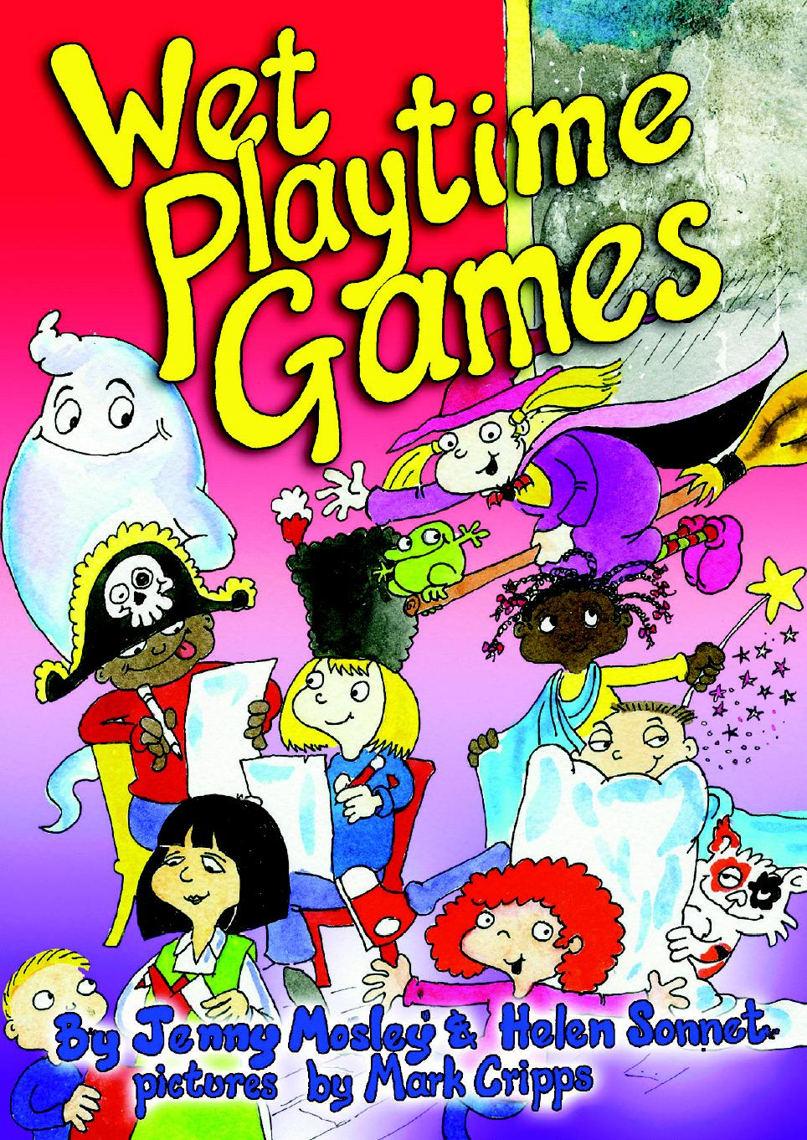
- Imagination.
- Self-awareness.
- Responsibility.
- Group cohesion.
- Teamwork.
- Relationship.

Tips on playing games

Try the games out with some willing colleagues.
Try to build a bank of games rather than getting in to a rut.
If a game doesn’t appear to be working stop and request help from the group.
Always prepare a few games so that you can ‘read’ the mood of the group.
Be aware that some games that involve touch might not be appropriate for some members of your class – allow them to be involved in other ways.
Do join in the games wherever possible.
Older children can be involved as leaders once they become familiar with the structure of the games.

Practical matters:

- Space.
- Materials.
- Time available.
- Group size.
(1 of 3)
- Age and ability.

Encouraging participation

Fostering a sense of joy.
Developing and building trust through ground rules.
Leadership styles – democratic.

Let’s play:

Beaky says:
Beaky calls out instructions to do with kindness. If the instruction is kind participants mime the action. If the instruction is unkind participants shout, “Oh no Beaky!”

Rocket Launch – p122 101 Games for Self-Esteem.

Musical Islands – p123 101 Games for Self-Esteem.

The Rule Of The Game – p96 101 Games for Self-Esteem.

Hand Writing – p29 101 Games for Self-Esteem.

Mirror, Mirror – p28 101 Games for Self-Esteem.

Electric Current
One person is chosen to be the electrician. They go out of the room. Other people are given roles such as the telephone, vacuum cleaner, doorbell, television – it is now 6 o’clock, washing machine, electric dog guard! One person is on as the generator. They start the current flowing by squeezing the hand of the person on their left. As the current goes around the appliances make their noises. When the current reaches the generator they send it back the other way. The electrician has to work out who the generator is.

Remote Control – p19 101 Games for Self-Esteem.

Pass The Keys – p207 Quality Circle Time.

Magic Box –place a mirror in a box wrapped in gift-wrapping paper. Tell the children that inside the box is a very, very special person. You will be passing the box around the circle and letting each child look inside the box. Can the children look and keep the identity of the special person a secret? At the end ask the children who the special person is?

Paper, Scissors, Rock – p17 101 Games for Self-Esteem.

Jigsaws – p16 101 Games for Self-Esteem.

Chain Reaction – p22 101 Games for Social Skills.

Who’s Talking Now? – p21 101 Games for Social Skills.
(2 of 3)

Back Writing – p18 101 Games for Social Skills.

Traffic Chant – p16 101 Games for Social Skills.

Hide and Seek – One child is chosen to be the detective and they stand outside of the circle. Tap several children on the shoulder and ask them to swap places. Use a large drape to hide one child in the middle of the circle. Invite the detective back into the circle to see who is hiding. If they are finding it difficult you can help them by asking the hidden child to say something in a disguised voice.

Scissors.

Mind reading.

True and false – participants work in groups of three. Each participant takes it in turns to tell three facts about themselves. Two facts will be true and one fact will be false. Can the other participants work out which facts are true and which facts are false?

Guess the leader – one person leaves the circle. One person is chosen to be the leader. They begin by making simple actions for the group to follow. Invite the person outside of the circle to rejoin and work out who is leading the actions.

Self esteem car wash – participants stand in two lines
facing each other. The two lines represent a car wash.
The two people at the front of the lines are two cars
desperately in need of a self-esteem car wash! As
they move down the middle of the lines participants
offer gentle strokes and words – well done
little car! At the same time the two lines make the noises of the car wash!

Ask participants to work in groups of five. Give each group a large sheet of flip chart paper. Ask one person from each group to come to the front and the leader whispers the name of an object to draw. The person returns to the group and draws the object. The first person draws the object and the first person that guesses returns to the leader and whispers the name of the object. They are then given the next object. The game continues until the first group finishes all the objects on the list.

Story Cue – p219 Quality Circle Time.

(3 of 3)

