IN AND OUT THE DUSTY BLUEBELLS

In and out the dusty bluebells (repeat three times)
c c c c
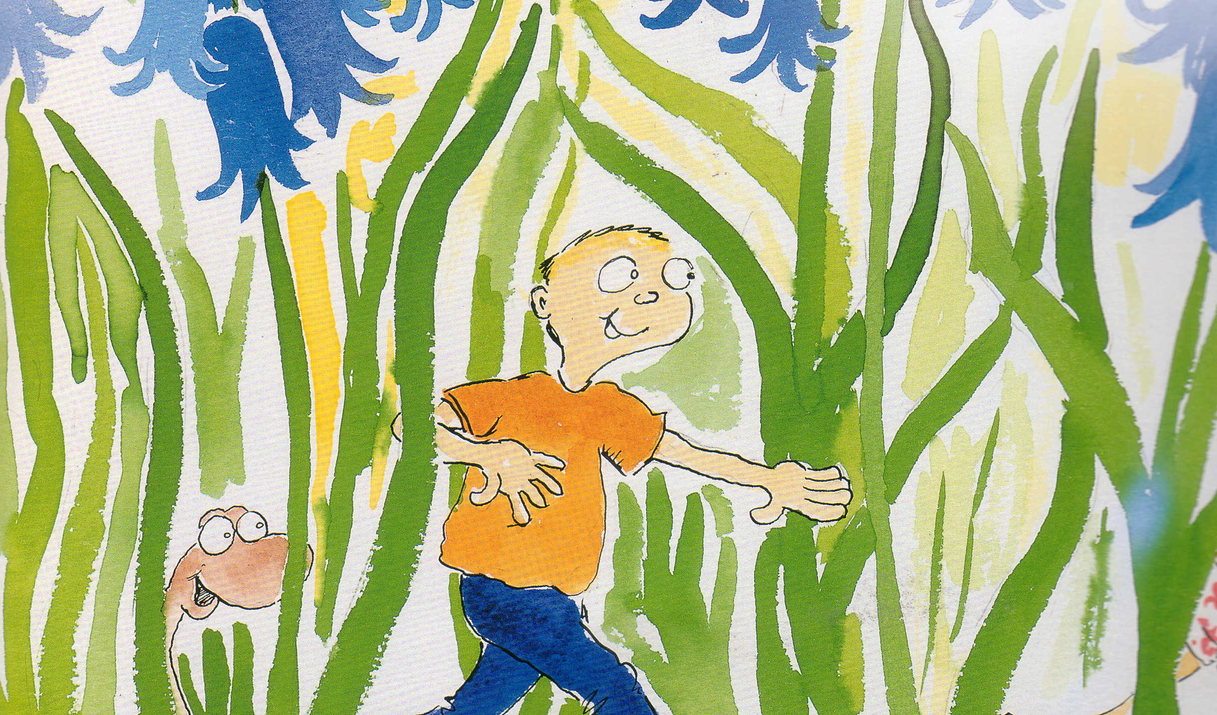

You shall be my master.
c c c

Pitter patter raindrops on my shoulders (repeat
c c c c
three times)

You shall be my master.
c c c

Children stand in well spaced circle. Child (A) is chosen and weaves in and out of circle for first three lines, then stands behind a child (B), and taps with alternate hands on shoulders of child (B).. At the end, the child (B) claps the waist of first child (A) from behind and they both repeat process. Children are gradually added to the chain until the circle becomes too small to be viable.
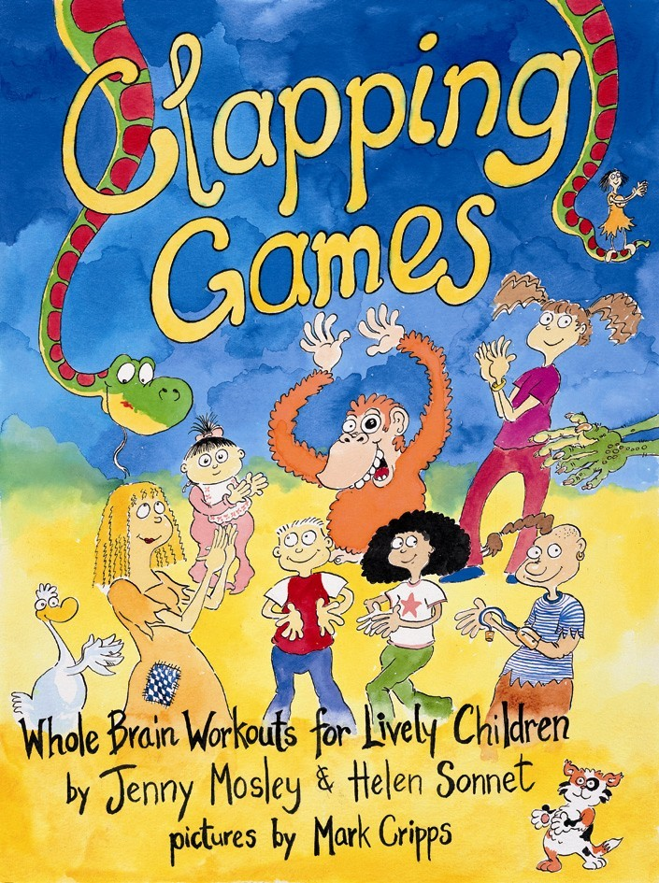

Key: C = Clap

Taken from Clapping Games by Jenny Mosley & Helen Sonnet
Illustrations by Mark Cripps

